Repl->

Open cmd/powershell

Write node

Write any code in js and execute

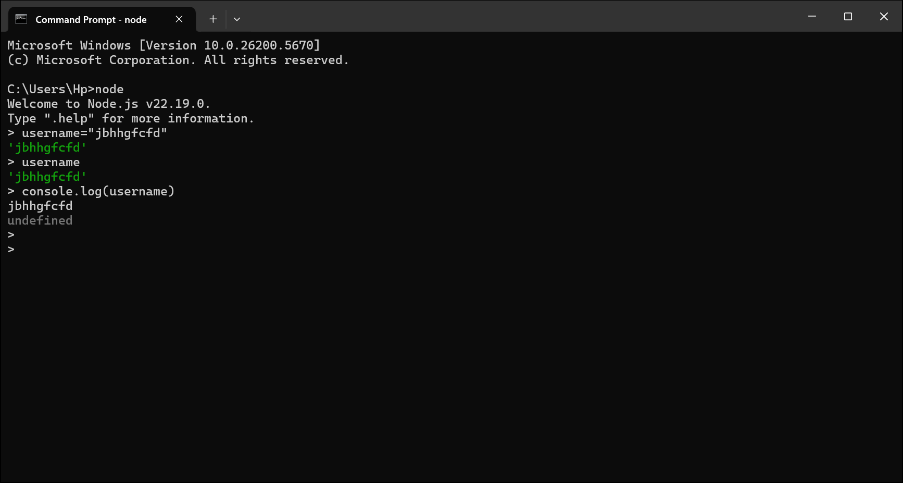

Function

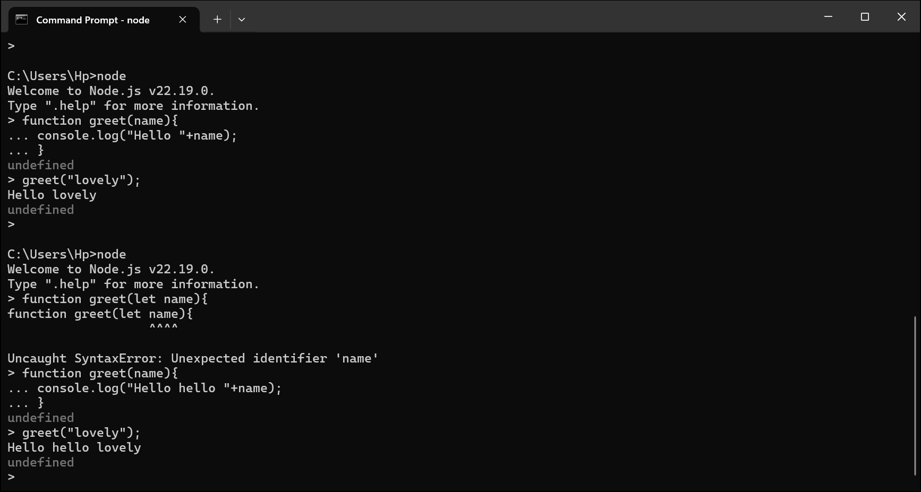

Any time we execute our code it will wrap in iffe function or module wrapper func but not used very much now

iife🡪immediately invoke function expression

Function (exports, require, module,__filename,__dirname){

}